

CS241: Software Design & Implementation
Faculty of Science, Technology and Environment School of Computing, Information and Mathematical Sciences
Final Examination Semester II 2018

Face to Face Mode

Duration of Exam: 3 hours + 10 minutes
Reading Time: 10 minutes Writing Time: 3 hours Total mark: 100
Question and Answer Booklet

Instructions:

This exam has three sections – A, B and C. All questions are c ompulsory.
Write your answers in this booklet.
Answer multiple choice questions on the multiple choice grid provided on page 7.
You may use non-programmable calculators.
This exam is worth 40% of your overall mark. Minimum pass mark for this exam is 4 0/100.

Hand this examination booklet to your supervisor when you complete the examination.

Section B: Basics of Software Design & Implementation (35 marks)

- Explain the differences between the two approaches to systems development (structured versus object- oriented). (2 marks)
In summary, the structured approach focuses on procedures and processes, whereas the object-oriented approach focuses on objects and their interactions. While the structured approach can work well for smaller, less complex systems, the object-oriented approach offers greater flexibility, reusability, and ease of maintenance, especially for larger, more complex systems.

- What is meant by three-layer design, and normally what are the three layers? (3 marks)
Three-layer design refers to a software architecture that divides the system into three distinct layers, each with specific responsibilities. These layers are:
- Presentation Layer (User Interface Layer): This layer handles the interaction between the user and the system. It is responsible for displaying data to the user and interpreting user inputs. It acts as the front-end of the system, where users interact with the software.
- Business Logic Layer (Application Layer): This layer contains the core functionality and business rules of the system. It processes the data received from the presentation layer, applies business logic, and passes the results to the data layer or presentation layer. It acts as the bridge between the user interface and the data.
- Data Layer (Persistence Layer): The data layer is responsible for managing and storing data. It interacts with databases or other data sources to retrieve, store, update, and delete data. This layer is independent of the presentation and business logic layers, ensuring separation of concerns.
The three-layer design enhances maintainability, scalability, and reusability by clearly separating concerns into layers, making it easier to manage and update the system.

- What term is generally used to describe the study of end users and their interaction with computers? (1 mark)
The term generally used to describe the study of end users and their interaction with computers is Human-Computer Interaction (HCI).

- One of the methods of documenting user dialogs is storyboarding. Explain what is storyboarding. Storyboarding is a method used to visually represent and document the sequence of interactions between a user and a system, typically in the context of user interfaces. It involves creating a series of sketches or images arranged in a sequence, much like a comic strip, that illustrates the flow of user interactions with the system. Each frame or panel represents a specific step or screen in the user’s journey, showcasing actions, system responses, and transitions between screens.
Storyboarding helps designers and developers visualize the user experience (UX) and the functionality of the system, allowing them to identify potential usability issues or areas for improvement before implementation. It's commonly used in designing software applications, websites, and other interactive systems, providing a clear and accessible way to communicate how the user will interact with the system at each stage of the process
- What is an API? Why is it important? (2 marks)

An API (Application Programming Interface) is a set of rules, protocols, and tools that allow different software applications to communicate with each other. It defines the methods and data formats that programs can use to request services or share data. APIs enable the integration of different systems, allowing them to work together without having to understand the underlying code of each system.

APIs allow developers to create new applications by using existing platforms, leading to faster development and innovation.
- List at least 3 reasons why integrity controls and security are designed into systems (3 marks)
Integrity controls and security are designed into systems for these reasons:
- Protect Data: Security ensures that only authorized users can access sensitive information, preventing unauthorized access or theft.
- Maintain Data Accuracy: Integrity controls ensure that data stays correct and consistent, avoiding errors or unwanted changes.
- Prevent Fraud: Security measures help detect and stop malicious activities or cyberattacks, keeping the system safe from harm.
These protections are important for ensuring that systems run smoothly, securely, and reliably.

- What are some of the advantages of using Design Patterns? List at least 3. (3 marks)

- Reusability: Design patterns provide proven solutions to common problems, allowing developers to reuse existing solutions rather than creating new ones from scratch. This speeds up development and reduces errors.
- Improved Communication: Using design patterns standardizes the way developers talk about solutions. It provides a common vocabulary that makes it easier for team members to understand, share, and discuss the design of a system.
- Maintainability: Design patterns promote best practices and structures that make code easier to maintain and extend over time. They help ensure the system is flexible and can be modified with minimal impact on other parts of the code.

Section C: Software Design and Implementation (applied tasks) (45 Marks)

Structure Charts (10 Marks)

- The following is an event-partitioned data flow diagram for a library system. Using transaction analysis technique, develop a structure chart for it.
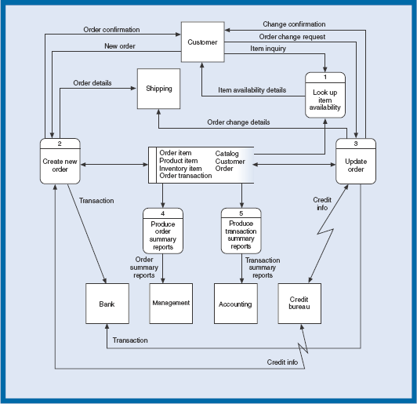

Main Control Module
|
|-- Look up Item Availability
| |
| |-- Query Item Database
| |
| |-- Return Item Availability Details
|
|-- Create New Order
| |
| |-- Validate Order
| |
| |-- Process Payment
| | |
| | |-- Communicate with Bank
| |
| |-- Update Inventory
| |
| |-- Record Order Details
| |
| |-- Generate Order Confirmation
|
|-- Update Order
| |
| |-- Validate Change Request
| |
| |-- Check Credit Information
| | |
| | |-- Communicate with Credit Bureau
| |
| |-- Modify Order
| |
| |-- Send Order Change Confirmation
|
|-- Produce Order Summary Reports
| |
| |-- Gather Order Data
| |
| |-- Generate Report
|
|-- Produce Transaction Summary Reports
|
|-- Collect Transaction Data
|
|-- Generate Transaction Report

Class Diagrams (5 marks)
- Refer to the class diagram for bank accounts below.

Customer |  | Account
-name  -address  -phone |  | -accountNumber  -balance  -dateOpened
 | 1 0..*

-interestRate
SavingsAccount
-checkStyle
-minimumBalance
CheckingAccount
Expand the model to show that there are special types of customers – personal and commercial. All customers have a name and mailing address. Commercial customers have additional attributes for credit rating, contact person, and contact person’s phone. Personal customers have attributes for home phone and work phone. Additionally, expand the model to show that the bank has multiple branches, and each account is serviced by one branch. Naturally each branch has many accounts. (5 marks)

Sequence diagrams (6 marks)
- Consider the following use case diagram for the Patient Record and Scheduling System.
Enter New Patient Information
Receptionist
Schedule Appointments
Record Office Visit Info

<<includes>>
Nurse
Enter Prescription Info
Print History Reports
View Patient History
Doctor

One of the events of the Patient Record and Scheduling System is the receptionist booking an appointment (Schedule Appointments). The following description provides an idea of how this can be achieved. (Assume the appointment is made by a new patient)

Patients either visit or call the receptionist to request for an appointment. The receptionist checks the system for available appointment times and advises the patient. The patient confirms an appointment time and provides details such as name, address, date of birth, and previous physician. The Receptionist then feeds this information in the system. After the system validates all the entered information, it saves the new patient record in the patient file, records the appointment time, issues a new patient # and produces an appointment confirmation. The receptionist then informs the patient of his new patient # and notifies him on the confirmation of the appointment time.

One of your team members has provided you with the following actor and design classes:

Appointment_UI
+CheckTimes(in time)
+MakeBooking(in time, in patientinfor)
+FormatResponse()
+DisplayConfirmation()

Appointment_Controller
+get_Available_Time(in time)
+MakeBooking(in time, in patientinfor)
+ValidateInfor()

Patient
+SetPatient(in patientinfor)

Receptionist
PatientDA
+SavePatient()

AppointmentDA
+AvailableAppointmentQuery(in time)
+SaveAppointment()

Appointment
+SetAppointment(in time)

Using the above information develop a sequence diagram for the Schedule Appointments use case. (6 marks)

Design Class diagrams (5 marks)

- Given below is a sequence diagram.
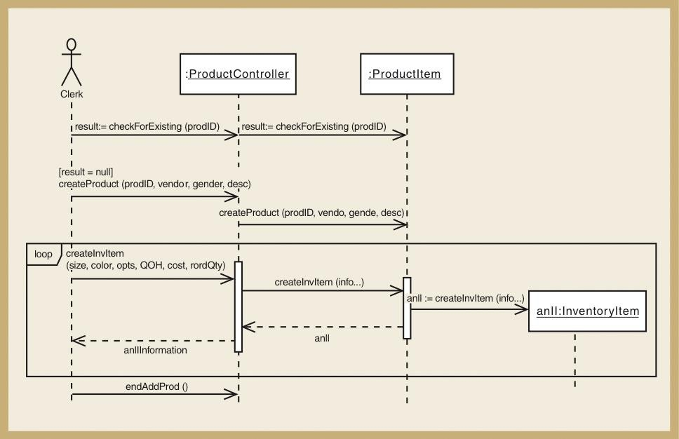

Model a design class diagram showing the methods of each class using the above sequence diagram. Do not show any attributes and only show those methods/messages shown in this sequence diagram. (5 marks)

Design Patterns (10 marks)
- List the steps of a Website Login use case based on a Model View Controller design pattern. The use case can result in a welcome screen or login failure. (5 marks)
In a Model-View-Controller (MVC) design pattern for a website login use case, the steps can be outlined as follows:
1. User Input (View)
- The user navigates to the login page and enters their username and password into the login form.
- The View captures this input from the user and sends it to the Controller.
2. Request Processing (Controller)
- The Controller receives the login request from the View with the username and password.
- It validates the input data (e.g., checks if fields are empty, if the data format is correct).
- The Controller then communicates with the Model to verify the user's credentials.
3. Authentication (Model)
- The Model accesses the database or other data source to check if the username and password match an existing user record.
- If the credentials are valid, the Model returns a success result (e.g., user details or a success message).
- If the credentials are invalid, the Model returns a failure result (e.g., an error message).
4. Displaying the Result (Controller)
- The Controller processes the result from the Model:
  - If the login is successful, the Controller redirects the user to the welcome screen (e.g., dashboard or homepage).
  - If the login fails, the Controller displays an error message and may prompt the user to try again.
5. User Feedback (View)
- The View is updated to either show:
  - A Welcome Screen with a personalized greeting or access to the user's account (if login is successful).
  - An Error Message indicating incorrect credentials or failed login attempt (if login fails).
These steps follow the MVC architecture by separating concerns between the View (user interface), the Controller (processing logic), and the Model (data and business logic), ensuring a modular, maintainable, and scalable design.

- Using the Observer pattern, draw a diagram which shows the use case where one set of scores may be displayed in 2 different formats. Use the following data: Course CS241, Grade A – 40%, Grade B – 25%, Grade C – 15%, Grade D – 20%. (3 marks)

- List an advantage and a disadvantage of the Model View Controller for a simple display of course score analysis use case such as in question 39. (2 marks)

Advantage of Model-View-Controller (MVC) for a Simple Display of Course Score Analysis:
Separation of Concerns:
- MVC separates the application's logic into three distinct components: Model, View, and Controller. This separation makes it easier to manage and maintain the application. For example, the Model handles the data (course scores), the View displays the data (UI for score analysis), and the Controller handles the user interaction and updates. This allows you to modify the UI (View) or the underlying data processing (Model) independently, without affecting the other parts.
Disadvantage of Model-View-Controller (MVC) for a Simple Display of Course Score Analysis:
Overhead for Simple Use Case:
- For a relatively simple use case like displaying course scores, implementing the full MVC pattern can introduce unnecessary complexity and overhead. In such a case, the application might be better off with a simpler design, where the user interface directly interacts with the data, rather than involving a Controller to mediate between the Model and the View. This could make development slower and the codebase harder to maintain than necessary for a simple task.

